Reappointment and Promotion Casebook Template
Documents Needed

Committee Documents:
To be uploaded by the R&P Coordinator

- Cover Page (No Table of Contents Necessary)
- Dean's Summary (Uploaded by the Dean’s Office)
- Recommendation of Department Head and Review Committee
- Digest Prepared by Reading Committee

Candidate Documents:
Italicized items are Mandatory. Please check with your R&P Coordinator if you are unsure of which documents to provide.
- Curriculum Vitae
- Statement of Career Goals
- Publications List (may be optional for Teaching and Systems Tracks)
- Recent Publications (may be optional for Teaching and Systems Tracks)
- Contract and Grant Support (this information will be supplied by the department)
- Faculty Course Evaluations (this information will be supplied by the department)
- Statement of Teaching Philosophy and Self Evaluation(optional for Research and Systems Tracks)
- Contributions to Education
- Professional Activities (previously also referred to as “Related Non-classroom Activities”)
- Evidence of External Reputation
- University, College, and Department Service
- Statement of Other Service Contributions
- Graduate Student Advising
- Student Service
Evaluations:
- External Evaluations
- Internal Evaluations
- Student Evaluations

Please see examples of Candidate Documents below.

PROMOTION TEMPLATE FOR TENURE TRACK FACULTY, TEACHING TRACK FACULTY, RESEARCH FACULTY AND SYSTEMS FACULTY

ITEMS IN BLUE ARE EXPLANATORY ONLY PLEASE CHANGE TO BLACK TYPE ONCE CORRECT INFORMATION HAS BEEN ENTERED

FACULTY REVIEW FOR

CANDIDATE NAME

CURRENTLY TITLE (SINCE DATE)

IN THE DEPARTMENT NAME

IN CONSIDERATION OF

REPPOINTMENT OR PROMOTION OR TRACK CHANGE TO POSITION

(EFFECTIVE JULY 1, 20XX)

SPRING OR FALL 20XX

Curriculum Vitae

CANDIDATE NAME

- Use the Subsection Header style from the drop down list for additional subsection headers; insert additional Subsections as needed.
- Use Body Text style for regular text
- Bullet Subsection lists

EDUCATION
List all degrees held, University Name, Year awarded

EMPLOYMENT
List current position and all former positions held

Statement of Career Goals

- Use the Subsection Header style from the drop down list for inserting subsection headers
- Use Body Text style for regular text
- Bullet Subsection lists

PLEASE BE SURE YOUR LIST CONFORMS TO THE CATEGORIES BELOW

PUBLICATION LIST
(May be optional for Teaching and System track Faculty, please check with your R&P Administrator.)

- Number entries consecutively throughout sections (as shown below)
- BOLDFACE Book Titles and Conference Proceedings
- ITALICIZE Names of Journals
- Delete Subsections with no entries
BOOKS
- Book
CHAPTERS IN BOOKS
- Chapter of Book
REFEREED JOURNAL PAPERS - PUBLISHED
- Refereed Journal Paper – Published
REFEREED JOURNAL PAPERS - ACCEPTED
- Refereed Journal Paper – Accepted
REFEREED JOURNAL PAPERS - SUBMITTED
- Refereed Journal Paper – Submitted
REFEREED CONFERENCE/WORKSHOP PAPERS
- Refereed Conference/Workshop Papers
UNREFEREED CONFERENCE/WORKSHOP PAPERS
- Unrefereed Conference/Workshop Papers
TECHNICAL REPORTS
- Technical Reports 1
OTHER PUBLICATIONS
- Other Publications
PATENTS AND INVENTION DISCLOSURES
- Other Publications
SOFTWARE ARTIFACTS
- Software Artifacts
VIDEO PRODUCTIONS
- Video Productions

RECENT PUBLICATIONS
(May be optional for Teaching and system track Faculty, please check with your R&P Administrator.)

Your three most significant publications since your last review should be combined and uploaded as 1 PDF.

CONTRACT AND GRANT SUPPORT

This information should be provided by the Department Business office, based upon information provided by the Department and Candidate.
- Include past, current, and pending (proposals which have been submitted but not yet funded).

Current

Title:
PI:
Agency:
Grant No:
Duration:
Amount:
Support:

Pending

Title:
PI:
Agency:
Grant No:
Duration:
Amount:
Support:

Past

Title:
PI:
Agency:
Grant No:
Duration:
Amount:
Support:

*Support: Please add Start and End Dates.
For past support: month+year to month+year: "Nov 2011 - Oct 2014"
For current support: month+year start and duration: "4 years, started Oct 2017"
For pending: duration only: "4 years"
*PIs: 1. Please add names of any co-PIs ("co-PI with XXX, YYY") and an indication ("sole PI") when that is the case.
2. If we are a sub, identify both sponsor and prime.
Example: PI: Faculty X (Sole PI at CMU; subcontract to UVA).
Agency: AFRL (Prime)

Note: "Duration" refers to the begin and end dates of the contract/agreement itself. "Support" is the % of effort and the length of time (e.g. "40% for 16 months" or "40% effort from April 2019 to August 2020") the candidate was actually supported by the contract/agreement, which may be shorter than the duration of the contract/agreement.

Faculty Course evaluation example

This information will be provided by the department from online records.

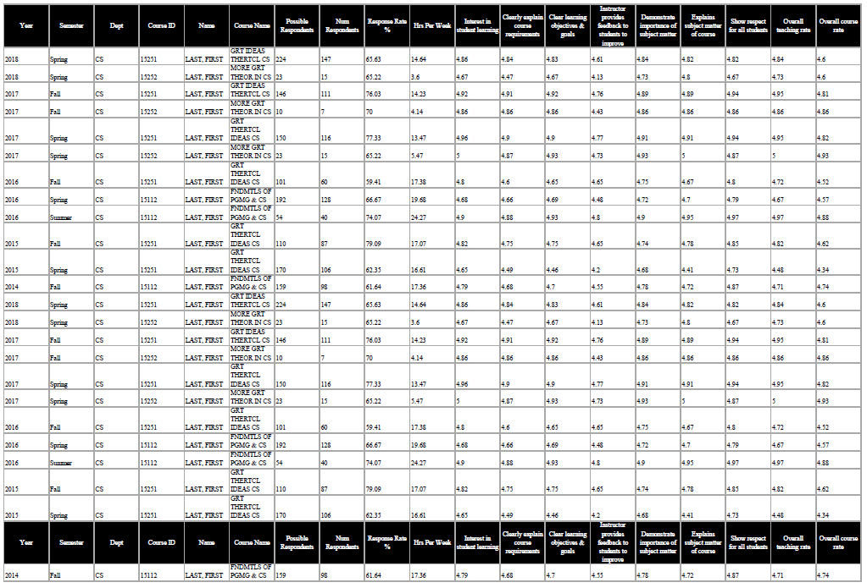

STATEMENT OF TEACHING PHILOSOPHY and Self Evaluation

This statement will outline your approach to your style of teaching, as well as self-evaluate past goals for instruction completed since the most recent reappointment or promotion. For cases within Research track or Systems track, this document is optional.

CONTRIBUTIONS TO EDUCATION

Apart from classroom performance and supervision; i.e., curriculum development, new programs, unsolicited evaluations by colleagues, teaching materials, textbooks, lecture notes, examinations, original laboratory exercises.

- Use the “Subsection Header” style from the drop down list for additional subsection headers; insert additional Subsections as needed.
- Use “Body Text” style for regular text

PROFESSIONAL ACTIVITIES

- Use the “Subsection Header” style from the drop down list for additional subsection headers; insert additional Subsections as needed.
- Use “Body Text” style for regular text
- Bullet Subsection lists using “indent list” style

Conference and workshop Committees
(List name of conference, role played – program chair, etc.)

Consulting
(List company name, number of days per year)

MembershipS in Professional Societies
(Include Offices Held)

Board MEMBERSHIPS

Other

EVIDENCE OF EXTERNAL REPUTATION

- Use the “Subsection Header” style from the drop down list for additional subsection headers; insert additional Subsections as needed.
- Use “Body Text” style for regular text
- Bullet Subsection lists using “indent list” style
Citations and Awards
- Award 1

InVited Talks
- Title, place, date

Seminars & Colloquia
- Title, place, date

OthEr
- Other

UNIVERSITY, COLLEGE, AND DEPARTMENT SERVICE

- Use the “Subsection Header” style from the drop down list for additional subsection headers; insert additional “Subsections” as needed.
- Use “Body Text” style for regular text
- Bullet Subsection lists using “indent list” style

University service and committee work

School and Department service and committee work

Other

Statement of Other Service Contributions

- Standards for promotions and reappointments among the faculty of the School include substantive contribution to improving the community, broadly defined. Reviewers of your case will value meaningful contributions demonstrating social responsibility. Candidates might document contributions to the mission or culture of their department, our school, or the university; or other contributions to their region, country, or the planet. Your statement, which should be no more than a page or two, might for example describe your personal contributions to diversity/equity/inclusion, environmental protection, human rights, adult literacy, or other area of social responsibility. See also CMU’s Vision, Mission and Values statement (https://www.cmu.edu/about/mission.html).

GRADUATE STUDENT ADVISING

- Use the “Subsection Header” style from the drop down list for additional subsection headers; insert additional Subsections as needed.
- Use “Body Text” style for regular text
- Bullet Subsection lists using “indent list” style

Current PHD Students
Student Name
- Year Entered
- Area of study/thesis title

Completed PHD Students
Student Name
- Thesis Title, Date of completion
- Current employer
- If co-advised, name of co-advisor

Undergraduate Senior Theses and Research Projects
Student Name
- Thesis/Project Title, Year

M.S. or PH.D. Thesis Committee SERVICE
Student Name
- Thesis Title, Year

Other
- Thesis Title, Year
- Other info here

STUDENT SERVICE AND TEAM MENTORING

Tutoring, advising of undergraduates, mentoring of project teams, oversight of fraternities, sororities, and clubs, chaperone for trips and competitions, etc.

LETTERS OF RECOMMENDATION FROM OUTSIDE CARNEGIE MELLON

This page will be completed by the Department Head’s office, based upon information provided by the Department and the Candidate.
Please find Guidance here: https://scsdean.cs.cmu.edu/reappointment-promotion/rpt-checklist.html

LETTERS OF RECOMMENDATION FROM CURRENT CARNEGIE MELLON FACULTY

This list to be provided by the Reading Committee Chair. Letters are requested by the
Department Head, not by the candidate.
Please find guidance here: https://scsdean.cs.cmu.edu/reappointment-promotion/rpt-checklist.html

lETTERS OF rECOMMENDATION FROM STUDENTS

This page will be completed by the Department Head’s office, based upon information provided by the Department and Candidate.
Please find guidance here: https://scsdean.cs.cmu.edu/reappointment-promotion/rpt-checklist.html

